Choosing
a
Password
Manager
_______________

There are many free, open source and commercial password managers to choose from. When trying to find the one that’s best for you, please keep the following in mind.

Use only well-known and trusted solutions. Be wary of solutions that have not been around for long or that have little or no community feedback.

Cyber criminals can create fake solutions designed to steal your information Make sure whatever solution you choose continues to be actively updated and patched, and be sure you are always using the latest version Password Managers .

It should be simple for you to use. If you find the solution too complex to understand, it is easy to make mistakes.

It should encrypt your passwords using industry standard, strong encryption. Be wary of any solution advertising a proprietary or unknown encryption solution.

It should run on all the different computers you use. Some more advanced versions also work on mobile devices.

A helpful feature is if your vault provides a means for synchronizing it across the different devices that you
use.

If it provides a means for synchronizing, it should encrypt locally before sending to the central system .It should provide tools for generating arbitrary passwords and help manage password expiration dates.

It should help you identify the relative strength of the passwords you’ve chosen.

_____________________________

Referenced from http://www.securingthehuman.org/newsletters/ouch/issues/OUCH-201310_en.pdf

LASTPASS FEATURES
________________________

- Automatic form fill

- Bookmarklets

- Secure Notes

- Share Credentials

- Shared Family Folders (Premium)

- Password generator

- Manual and automatic password changes for sites

- Virtual Keyboard

- Multifactor authentication

- One Time Passwords (OTPs)

- Auditing stored passwords

- Command line interface ( Enterprise version )

- Identities

- Importing and exporting WiFi passwords

PRESENTATION OUTLINE
_____________________

- Introduction

What is a password manager?
How do they work?

- Types of Password Managers

Overview of types
Detailed list of PM's
Advantages / Disadvantages

- Overview on LastPass

Brief intro on LastPass
Overview

- Security Issues

How safe are they really?
Sweep Attacks
Injection & Extraction Code
Possible Fixes

- Conclusion

My opinion



CIS-1290 Holland College
April 23, 2015

Password
Managers

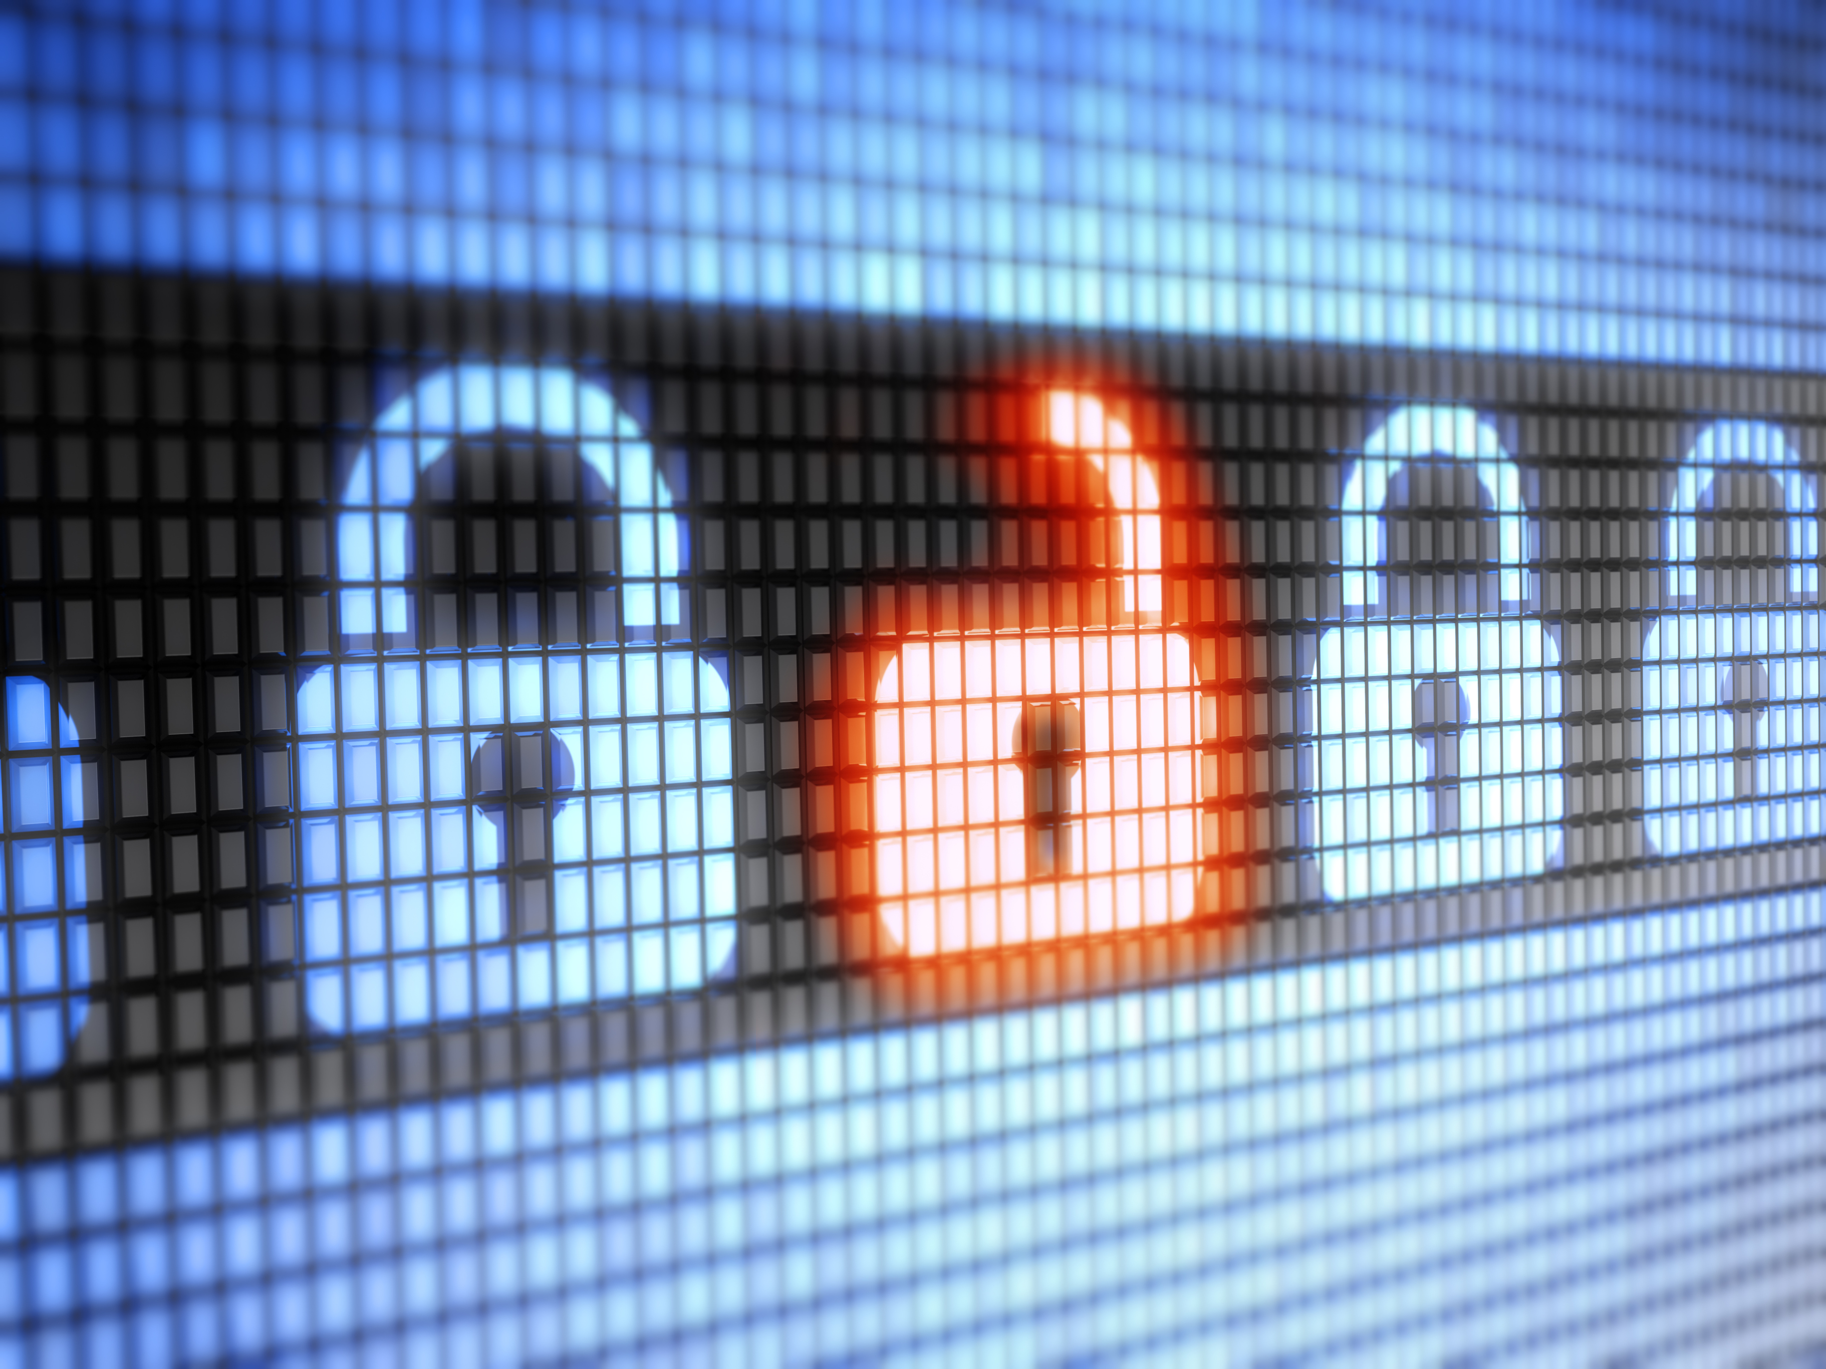

SME Presentation
by
Christopher Sigouin

